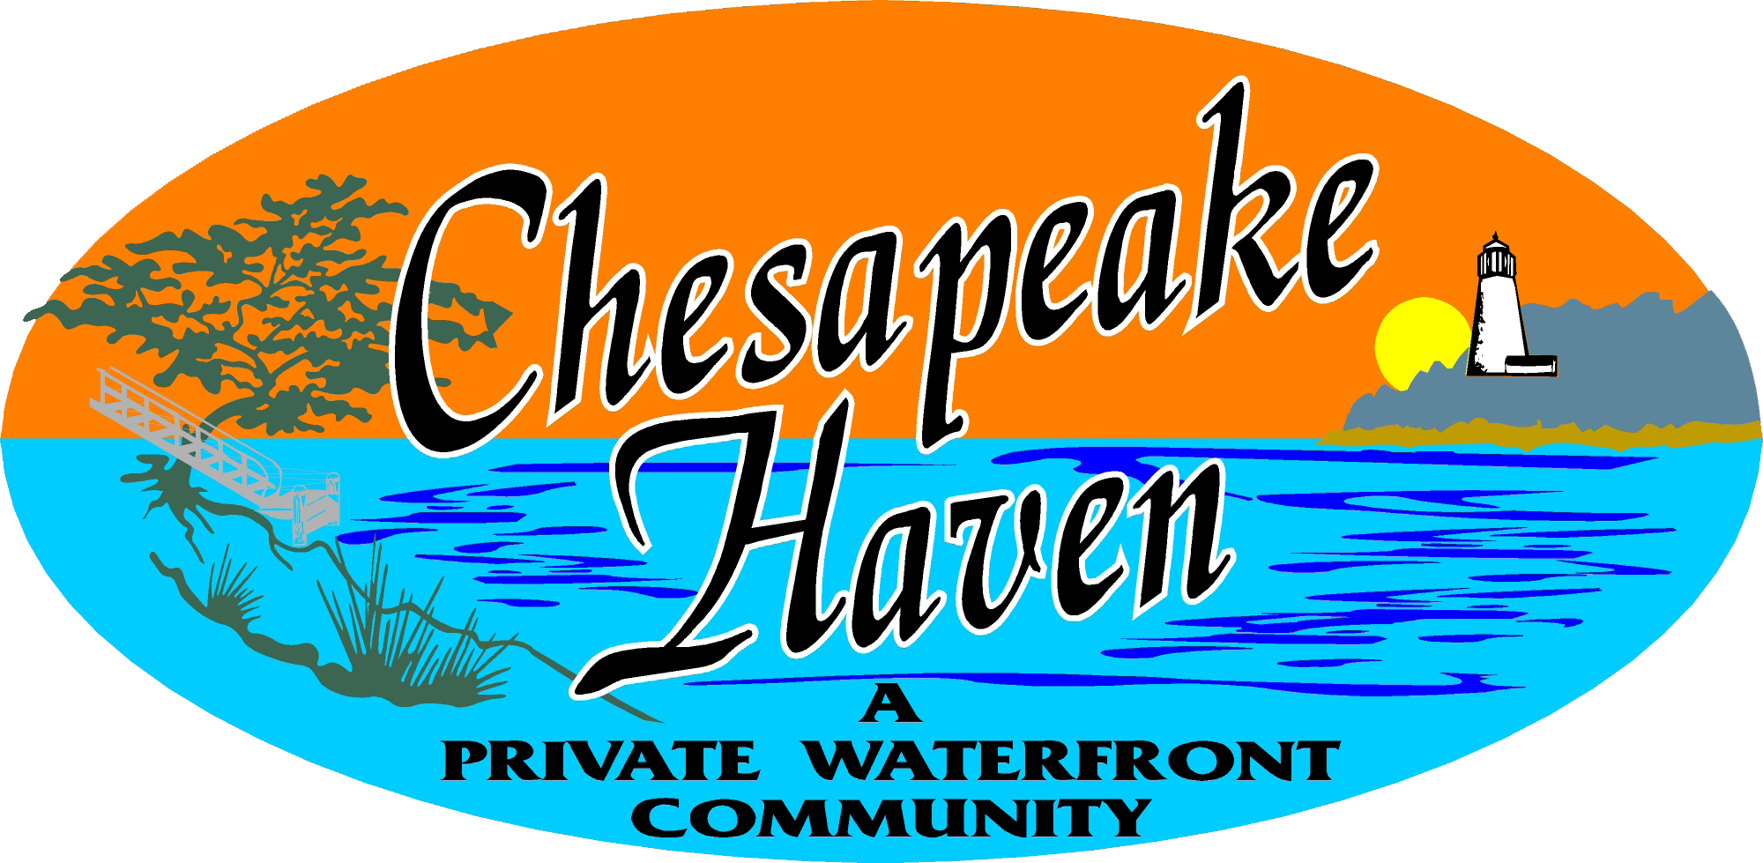
CHESAPEAKE HAVEN HOMEOWNERS ASSOCIATION, INC. 158 Ohio Avenue Earleville, MD 21919
www.chesapeakehaven.com
Spring General Meeting – May 16, 2020 @ 10:00am
Hi Neighbors!
It is that time again. Spring is here! We originally were moving the Spring General Meeting to May to align with the results of our pending Beach Restoration Grant Application. We were hoping to hold a special meeting in April to provide an opportunity to meet with key supporters and answer your questions.
However, with the current Coronavirus Pandemic we cannot move forward with scheduling these two important events. As such, when we get to the other side of this we will be able to schedule these meetings. Because we also have to follow the MD HOA laws for meeting notifications, we will do our best to work within these guidelines.If during this time you have questions please feel free to contact one of the HOA Board members.
Below is a quick recap from the past season, and what’s coming up for Spring/Summer 2020:
1.) Election for the Board of Directors recently took place for the 2020-2021 term. As of this time the Board of Directors consists of (7) members and they are:
- President Ted Heath tedheath@msn.com
- Vice President Jan Bickford Morrow jp.bickfordmorrow@gmail.com
- Treasurer Jinni Burns sandybagger1@msn.com
- Secretary Brian Bennett sgtbb2001@gmail.com
- Marshall Leffew, Director xenolith2u@gmail.com
- Sarah Jensen, Director Jtsljensen@msn.com
- Shirley Jones, Director Shirley@ginns.net
2.) A Beach Renovation Project is in the works with assistance from the State of Maryland via a grant process. We hope that the recent grant application is approved in May and that work can begin to renovate our beach as it is an asset of the community. The Beach also adds value to our properties and not to mention recreational value. As many of you may know, a ballot was sent out recently and the board was approved to allocate monies towards this project. The voting results were 29 in favor and 6 against. This tabulation of votes was handled by the Kent County League of Women Voters. A notarized letter is on file for those who wish to verify.
To provide all of you with the details of that project, a new page has been added to the Chesapeakehaven.com web site. As we have updates on the pending decisions they will be posted there.
3.) Fishing season is here. Our beach is for residents & their guests only. We must insist that if you have a guest that is fishing on the beach you must accompany them. This way we will weed out any issues before they become a problem. DNR will be notified when the others are there to check for proper licensing and Cecil County Sheriff’s office will be notified for trespassers. It is a private community and Cecil County will intervene for trespassing. Let’s all work together to keep our community nice.
Contact the DNR if you feel there are fishermen in the beach area that do not belong. Contact the DNR @ 800-628-9944 and Cecil County Sheriff’s office @ 410-996-5500.
4.) Mosquito spraying will begin at the end of the May 2020. Contact John Molyneux @ jemolyneux@gmail.com with any questions that you may have regarding this spraying.
5.) Enclosed in this newsletter is a form generated by Jinni Burns requesting an updated address, email for our members. Please fill out this form and return it to Jinni at your earliest convenience. Jinni is asking that everyone return this form to her as she is going to be developing a community directory to distribute to all members.
6.) Just a reminder, please keep your property boundaries adjacent to the roads cut back and free of obstacles that may interfere with travel, deliveries or emergency vehicles responding to the community. We thank you in advance for your assistance in this matter.
7.) Please submit any questions that you may have to the board by mailing your questions to 158 Ohio Avenue, Earleville, MD 21919 or by emailing them to any one of the board members listed above.

